
CS673 Software Engineering
Team 2 - Rental Ninja
Software Test Document

Team Member | Role(s) | Signature | Date
Yongjing Wu | Team Lead | Yongjing wu | 09/08/2024
Jiacheng Ding | Security Lead | Jiacheng Ding | 09/08/2024
Yueyang He | Design and Implementation Lead | Yueyang He | 09/08/2024
Xueqi Zhou | Requirement Lead | Xueqi Zhou | 09/09/2024
Rundong Zhong | Configuration Lead | Rundong Zhong | 09/08/2024
Xiang Zhang | QA Lead | Xiang Zhang | 09/09/2024

Revision history
Version | Author | Date | Change
v1.0 | Jiachen Ding | 09/09/2024 | initial
v1.1 | Yongjing Wu | 20/09/2024 | Testing Summary
v2.0 | Xiang Zhang | 04/10/2024 | Update Testing Report
v2.1 | Xiang Zhang | 07/10/2024 | Update Testing Report

Testing Summary
Manuel Tests Reports
Automated Testing Reports
Testing Metrics
References
Glossary

Testing Summary

Test Objectives
    - Verify that all essential functionalities are implemented correctly.
    - Ensure integration with other services is seamless.
    - Validate the security features of the platform.

Test Criteria
    - All test cases must pass without errors.
    - No critical or high-severity defects should remain unresolved.

Test Scope:
    - Unit Test
    - UI Test
    - API Test
    - Integration Test
    - System Test
    - Security Test
    - Initial test code added for qa-backend and qa-frontend, covering core functionalities for both backend and frontend components.

Manual Testing Report

Issues Found and Recommendations (Iteration 2)
- Access to Profile Page Without Logging In:
  - Issue: Users can access the profile page without being logged in, allowing them to view and update the default name and email.
  - Recommendation: Implement access control. Check the user's login status before allowing access to the profile page. Redirect to the login page or display a prompt if the user is not logged in.
- File Upload Occurs Immediately Without Confirmation (Profile Picture):
  - Issue: When users select a file, it is uploaded immediately without any confirmation step.
  - Recommendation: Add a confirmation step. Display a preview of the selected file and provide "Save" or "Confirm" buttons. Proceed with the upload only after the user confirms.
- Ability to Change Password Without Logging In:
  - Issue: Users can change their password without being logged in, which is unusual behavior.
  - Recommendation: Ensure users are logged in before allowing them to change their password.
- Ability to Post Without Logging In:
  - Issue: Posting is allowed without user authentication, which may pose a security risk.
  - Recommendation: Enforce user authentication before allowing posts.
- "About Us" and "Contact Us" Pages Are Empty:
  - Issue: These pages currently do not display any content.
  - Recommendation: Add content retrieval from the backend for these pages to ensure relevant information is displayed.
- UI Elements Obstructed; Adjustments Needed for Font and Element Sizes:
  - Issue: Some UI elements are obstructed or overlap.
  - Recommendation: Adjust the dimensions of fonts and UI elements to ensure a clear, unobstructed user interface.

Testing Case Sample:
Test Case ID: TC0001
Test Name: Test User Post API
New or Old: New
Test Items: post()
Test Priority: High
Dependencies: None
Preconditions: The database must contain project data.
Input Data: JSON payload with project details.
Test Steps:
Send a GET request to /apiv1/rental_nijia/post.
Postconditions: The response should contain a success.
Expected Output: A JSON array of responses.
Actual Output: None
Pass or Fail: Pass
Bug ID/Link: None
Additional Notes: None

Testing Report Form:
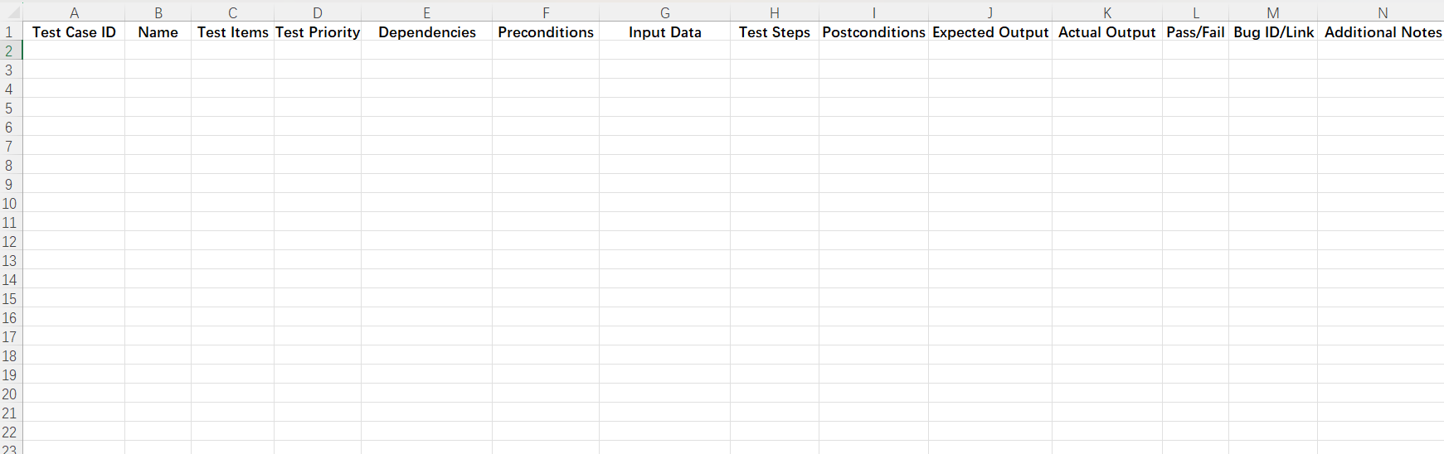

Automated Testing Report
Unit Tests: JUnit for backend tests and Jest for frontend components.
Integration Tests: Postman for API testing.
E2E Tests: Cypress for testing the complete user flow.

Initial tests have been added to qa-backend using JUnit for backend API verification, and qa-frontend using Jest to test key Vue components.
Below is the screenshot showing the successful execution of the test case TC0001, which verifies the proper functioning of the User Post API.
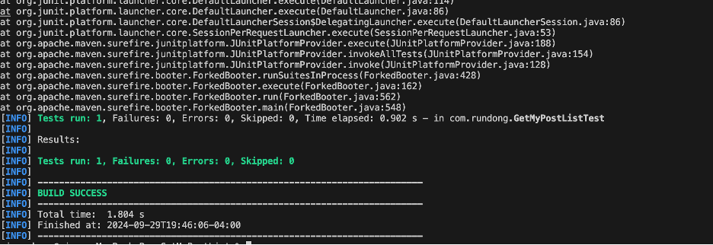

Testing Metrics
Number of test cases: 20 test cases
Test coverage: 85% code coverage
Defect rate: 5%
Resolution rate: 100% of identified defects were resolved.

References

Glossary

